Assigement-6

Find sum of the average in array

Program:

//Inside Main

class Avg

{

public static void main(String args[])

{

float avg;

int sum=0;

int a[]={10,20,41,52,23};

for(int i=0;i<a.length;i++)

{

sum+=a[i];

}

avg=(float)sum/a.length;

System.out.println("Float Average is:"+ avg);

}

}

Output:

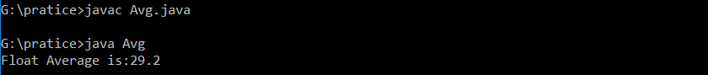

Find sum of operation in array

Program:

//Inside Main

class Elements

{

public static void main(String args[])

{

double div;

int a[]={60,50,14,7};

for(int i=0;i<a.length;i++)

{

if(a[i]==a[a.length-1])

{

break;

}

int sum=a[i]+a[i+1];

System.out.println("--------------------------------------");

System.out.println("Sum is :"+sum);

int sub=a[i]-a[i+1];

System.out.println("Sub is :"+sub);

int mul=a[i]\*a[i+1];

System.out.println("Mul is :"+mul);

div=a[i]/a[i+1];

System.out.println("Div is :"+div);

}

}

}

Output:

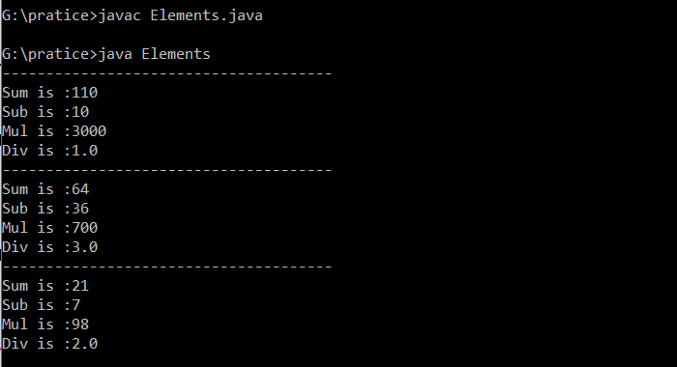

Find sum of arthematic operation

Program:

//Inside main

class Diff

{

public static void main(String args[])

{

int ar[]={12,13,14,15,16,17,18,19};

int b[]=new int[ar.length/2];

int c[]=new int[ar.length/4];

int d;

int j=0;

int k=0;

for(int i=0;i<ar.length;i++)

{

b[j]=ar[i]+ar[++i];

System.out.println(j+" Sum is :" +b[j]);

j++;

}

for(j=0;j<ar.length/2;j++)

{

c[k]=b[j]-b[++j];

System.out.println(k+" Sub is :" +c[k]);

k++;

}

for(k=0;k<ar.length/4;k++)

{

d=c[k]\*c[++k];

System.out.println(k+" Mul is :" +d);

float e=(float) (d/ar.length);

System.out.println(k+" Div is :" +e);

}

}

}

Output:

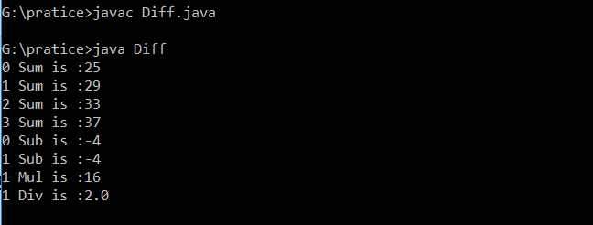

Find even or odd

Program:

//Inside Main

class Array

{

public static void main(String args[])

{

int a[]={10,17,12,56,81,78};

for(int i=0;i<a.length;i++)

{

if(i%2==0)

{

System.out.println(a[i]+": is Even Number");

}

else

{

System.out.println(a[i]+": is Odd Number");

}

}

}

}

Output:

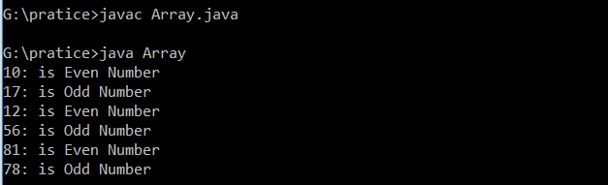

Find vowels and consonants

Program:

//Inside Main

class Vowels

{

public static void main(String args[])

{

char b[]={'a','r','t','i','h','u'};

for(int index=0;index<b.length;index++)

{

if(b[index]=='a' || b[index]=='e' || b[index]=='i' || b[index]=='o' || b[index]=='u')

{

System.out.println(b[index] +": is Vowels Alphabet");

}

else

{

System.out.println(b[index] +": is Consonents Alphabet");

}

}

}

}

Output:

